Intelligent Intrusion Detection System for Securing Industry 4.0 Environments Using Machine Learning
UshaRani Munagoti ^{1,a)}
Pratheek Reddy Reddammagari ^{2,b)}, Lok Vinay Thiruveedhula ^{3,b)},Dinesh Reddy Pulsani^{4,b)}

Author Affiliations
^{1,2,3,4)} Department of Information Technology, Gokaraju Rangaraju Institute of Engineering and Technology (GRIET),
affiliated with JNTUH, Bachupally, Hyderabad, India.

Author Emails
^{a)}Corresponding Author: cse.musharani@gmail.com
^{b)}pratheekreddyreddammagari18@gmail.com
^{b)} thiruveedhulaloki@gmail.com
^{b)} dineshreddy200419@gmail.com

Abstract: Abstract Industry 4.0 facilitates intelligent manufacturing by adopting Industrial Internet of Things (IIoT), cyber-physical systems, cloud computing and real time exchange of data. Although these technologies make industrial networks more automated and efficient, they also present complex cyber threats to industrial networks. Conventional security systems like firewalls and signature-based antivirus programs are not always enough to capture dynamic and changing attacks to smart factory infrastructure.In this paper, a proposal has been made of a Machine Learning-based Intelligent Intrusion Detection System (IDS) that specifically addresses the security of Industry 4.0 infrastructure. The system uses the traffic in the industrial network to understand what is considered as normal and malicious in real time. NSL-KDD dataset is used as a benchmark dataset to model the intrusion situations which are applicable in the industrial communication networks. The most important preprocessing steps are data normalization and categorical feature encoding and feature selection to optimize the efficiency and robustness of the model, which can be applied in real-time to an industrial environment.XGBoost classifier is trained on the top ten network features, which provides an optimal cost-to-sensitivity approach in detecting any object that can be implemented in real-time in an industrial facility. A FastAPI-based backend server is used to deploy the trained model to make predictions based on live prediction requests. The interface has a React-based interactive dashboard that can be used to monitor and input network parameters and connect to the backend via the REST API calls. As per the experimental assessment, the proposed IDS is a scalable, efficient, and highly accurate measure of securing the smart manufacturing landscape in Industry 4.0 against the changing cyber threats.

INTRODUCTION

Due to the emergence of Industry 4.0, the character of conventional manufacturing has been changed to high-connected and smart manufacturing environments. Smart factories have now integrated Industrial Internet of Things (IIoT), cyber-physical systems, cloud computing, and real-time data exchange to automatize and make them efficient and make decisions based on the data. However, such an improved connection has also turned cyberattack surface big, and hence, industrial systems are turning vulnerable to sophisticated and dynamic cyber-attack.

Unlike the traditional IT networks, Industry 4.0s have real-time networked sensors, programmable logic controllers (PLCs), robotic systems, and cloud systems. The legacy security measures, such as firewalls and signature-based antivirus software, lack the proficiency to determine advanced persistent threats, zero-day attacks and abnormal behaviors against industrial control systems. The biggest challenge of the provision of smart manufacturing systems is the capability to detect dynamic patterns of intrusions in such complex cyber-physical systems.

In order to eliminate this challenge, this paper proposes a Machine Learning-Based Intelligent Intrusion Detection System (IDS) to industry 4.0 network. The key issue is to develop an intelligent and dynamic security architecture capable of detecting normal and abnormal traffic of industrial networks in real-time. The system utilizes the recent machine learning techniques, and more specifically, the XGBoost classification algorithm, and powerful data preprocessing and feature selection algorithms in determining the object in the image with a high level of success and at the same time in a computationally efficient way.

The following framework is a combination of a prediction engine (as a backend) and an interactive visualization dashboard to ensure that the centralized monitoring and decision support of industrial operators would be made available. The system will attempt to increase the resiliency of cybersecurity in smart manufacturing environments and solidify the secure online transformation of Industry 4.0 systems with the set of real-time intrusion detection and intelligent analytics.

LITERATURE REFERENCES

The topic of industrial network security is not only a research area of the utmost importance due to the advent of Industry 4.0 technologies, including the Industrial Internet of Things (IIoT). Scholars have investigated machine-learning and deep-learning techniques to enhance the intrusion detection systems in the modern interconnected environments.

An experimental study, which compares the various machine-learning approaches to intrusion detection, is presented by Kathryn -Ann Tait, Jan Sher, Fehaid Alqahtani, Awais Aziz Shah, Fadia Ali Khan, Mujeeb Ur Rehman, Wadii Boulila and Jawad Ahmad (2021). Performing the study on the analysis of a set of classifiers with a benchmarking to intrusion datasets, the authors discovered that the classification with high rates of detection was both in binary attack set-ups, and in multi-class attack set-ups. They also however, indicated that the algorithms performance varied based on the datasets and hence their use in heterogeneous Industry 4.0 systems where the traffic patterns are significantly different than those of IT-based networks is tricky [1].

The model suggested by MA Kumar et al. (2022) is a hybrid deep-learning immune system that is developed to identify intrusion in healthcare networks. Although the architecture is unique to a healthcare setting and is aimed at protecting sensitive and critical infrastructure, this can be applied to Industry 4.0. Its inability to be applied in real time industrial systems that involve edge devices with limited ability is however necessitated by the requirement to possess intensive computing power [2].

Z. Li (2024) performed a deep-learning-based IDS models analysis, where convolutional and recurrent neural networks are applied to identify new cyber threats. The article has emphasized the flexibility of the deep models to new malpractices in attacks that is very important in sustaining the constantly evolving smart-factory ecosystem. The scalability of distributed industrial systems is however hampered by the fact that, big labelled data and high-performance computers are required [3].

Buyuktanir et al. (2025) in their article considered the federated learning approach to intrusion detection and focused on the privacy control and distributed learning advantages. Federated IDS has the potential to support protective collaboration in a variety of smart factories and IIoT networks of nodes in Industry 4.0. However, it is noted that the issues concerning the model-aggregation intricacies and the non-homogeneous nature of industrial information have been a prevalent situational challenge to scalability [4].

The next alternative that R. Kumar and M. (2024) suggest is a hybrid CNNLSTM model that can operate on both spatial and time-related data about network traffic. The model showed high detection rates and low false-alarm rates on benchmark data, including both NSL-KDD and CICIDS2017. This is effective though it is expensive in calculation which makes it to be infeasible in situations where the high frequency industrial communication networks need the rapid response rate [5].

The article by L. Zhao and P. C. Chen (2023) was dedicated to the issue of anomaly recognition with the use of stacked autoencoders and feature-fusion. Their unmonitored approach also enhances the detection of the zero-day attacks, which are gaining relevance in Industry 4.0. However, it was not so high in the heterogeneous network structures that appear in the industry cyber-physical systems [6].

IoT-network strategies and blockchain technology and IDS have been applied by S. Ahmed and R. Patel (2025) to increase the transparency and trust management levels in the network. Blockchain-based Industry 4.0 IDS is capable of preventing single point of failure and increasing the integrity of data. Nonetheless, real time intelligent manufacture systems have the problem of latency and computing overhead [7].

H. L. and D. P. (2024) investigated the application of transfer learning in the detection of network intrusion. It does not need large documented datasets and it is able to converge rapidly by utilizing trained models. It is also useful when in the industry 4.0 world where data is distributed in a heterogeneous manner. However, it is possible that the accuracy of detection could be affected by the process of domain-adaptation in the cases when a powerful difference emerges between the source and the target industrial datasets [8].

Y. Zhang, X. Wang and L. Sun (2023) offered a system of edge-based intrusion detection of the industrial IoT. They added lightweight machine-learning models in the edge layer in that way the latency is minimised and real-time detection is maximised in intelligent manufacturing systems. The research demonstrated better response rate and reduced reliance on cloud services hence making it an Industry 4.0 designs. Nevertheless, the advanced multi-stage cyberattacks may exceed the low computing processes of the edge devices and sabotage the performance of detection [9].

A. Verma and S. Reddy (2024) developed an adaptive intrusion detection system using the reinforcement learning algorithm, which is implemented on the cyber-physical production systems. This model is dynamic by the fact that parameters used in detecting changes are adjusted in terms of network behaviour, which enhances resistance to emergent threats to industries. The architecture was rather dynamic in virtual smart-factory networks. However, reinforcement learning models require ongoing training and fine-tuning; hence, complexity may arise on large-scale industrial scale [10].

As indicated in the article by Martinez, P.Oliveira and T.Huang (2025) it suggested a cloud-based framework of Industry 4.0 smart factories when it comes to anomaly detection. Distributed IIoT nodes store and analyze data using deep learning in the cloud in their architecture. The architecture improves cross-factory threat intelligence and scalability. Nonetheless, the data privacy and transmission time and reliance on a stable connection will still remain an issue at the time of implementing real-time industrial cybersecurity implementation [11].

METHODOLOGY

The architecture of the suggested system is the Intelligent Intrusion Detection System (IDS) that is designed on the basis of the principles of the Machine Learning and targeted at safeguarding smart manufacturing plants of Industry 4.0. The model will detect established and novel industrial network cyber threats to industrial network systems, including Industrial IoT (IIoT) systems, programmable logic controllers (PLCs), and manufacturing systems connected to the cloud.
Its most important detection engine is based on the XGBoost classifier and trained in the NSL-KDD benchmark dataset in order to characterize the trends of intrusion behavior. Although NSL-KDD is a standard dataset used to study the intrusion detection, feature engineering and pre-processing operations is customized to meet the characteristics of industry-based communication. The data preprocessing includes data normalization, categorical encoding of features and feature selection to enhance the computer performance and model robustness.
The model is trained using the ten most significant network features, and such selection is made to provide the model with an optimal detection and real-time performance, which is reasonable to use in an industry. The trained model is served as a FastAPI-based backend service to assist in real-time monitoring of the industry. Network features are inputted in this API layer in the form of industrial traffic parameters and prediction requests are processed with small latency. The system announces network activity to be either normal industrial operation or intrusion attempt and, therefore, helps in a quick decision making in smart factory environment.
The front-end interface is the type of an interactive monitoring dashboard, an interactive React.js dashboard. The operators of industries or system administrators are able to enter the network parameters and it immediately displays the results of the detection. Pie and bar charts are used to give analytical outputs in the dashboard and therefore, it becomes easy to decipher intrusion trends and awareness of operations in regard to cybersecurity.
Unlike the traditional systems of detecting intrusion based on rules, the proposed model employs machine learning intelligence to ensure that it remains abreast with the dynamic cyber threats as compared to the conventional systems. It has an interoperable architecture and can be extended to distributed Industry 4.0 infrastructures and therefore can be connected to industrial automation networks, IIoT devices and digital manufacturing systems.

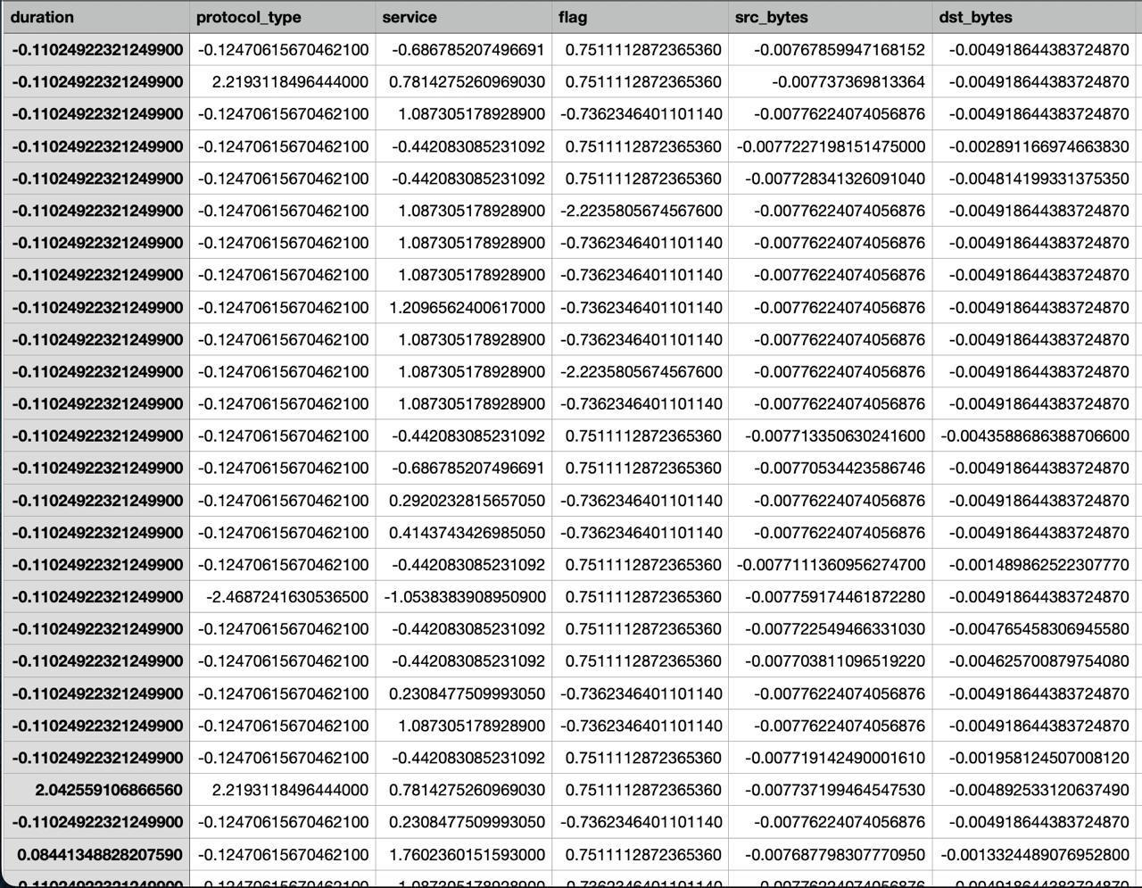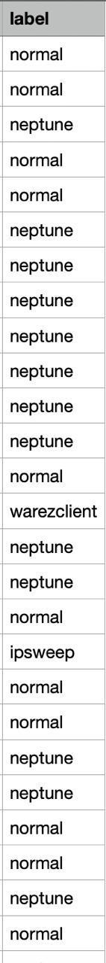
FIGURE-1: Sample Data from the Dataset
The pre-processed sub-sample of the NSL-KDD data, which was utilized during the training of the proposed Industry 4.0 Intrusion Detection System, is presented in figure 1. It assigns certain network -traffic characteristics like duration, protocol type, service, flag, source bytes and destination bytes with respective labels as normal or intrusive activity. The values are already in normalised and coded form such that they are machine learnable. This information acts as an input in the case of the XGBoost model training to be done that would differentiate between the legitimate smart-factory communication and cyber threat in Industry 4.0 contexts.

Preprocessing Data
A structured data preprocessing pipeline is used in order to guarantee efficient and precise intrusion detection in Industry 4.0 smart manufacturing setups. Because industrial networks produce various and high-frequency communication data by IIoT devices, controllers, and cyber-physical systems, preprocessing is an important factor to enhance the reliability of the model and real-time performance.
- Load Dataset: Load Dataset - NSL-KDD dataset is used as a benchmark dataset which is a represented data of labeled network traffic data which has both normal and attack patterns. Though it was initially designed to be used on conventional networks, it forms a basis dataset to emulate intrusion behaviors that can be used on an Industry 4.0 industrial communication system.
- Select Features: In order to make the deployment of the real-time in smart factory environment possible, the top 10 most important features of the network are chosen. The process of feature selection minimizes the computational load and provides quicker processing, which is quite important in the industrial control systems and IIoT networks with latency-sensitive requirements.
- Encode Categorical Variables: Of the categorical variables in the industrial network traffic, there are protocol type, service type, and connection flags. Label Encoding techniques convert these categorical variables into numerical forms. This is done to make sure that there is compatibility with machine learning algorithms and that vital communication features that are important in intrusion detection are maintained.
- Normalized Features: To further enhance convergence and increase the higher detection accuracy, numerical features are scaled by a Standard Scaler. Normalization: The aspect of making sure that feature magnitudes do not skew the model is important to ensure that the model maintains the same performance in the heterogeneous Industry 4.0 network environment.

Model Training

- Split Data: The cleaned dataset is separated into training and testing datasets; the data is split into 80 and 20 percent training and testing respectively. This division has the effect of guaranteeing that the model receives enough data on industrial network traffic to learn as well as be tested on samples that are unknown to it to quantify its ability to generalize in the real world. Initialize Model: XGBoost classifier is chosen because it is a high-performance, robust, and efficient engine in terms of computations.
- Initialize Model: An XGBoost classifier is selected as the core detection engine due to its high performance, robustness, and computational efficiency. Optimal hyperparameters are configured to balance detection accuracy with real-time performance requirements, which is especially important for latency-sensitive Industry 4.0 environments.
- Train Model: The feature of the XGBoost model is trained with industrial network traffic characteristics of the training set. This step is the time when the algorithm works out how to differentiate between regular and possible intrusion attempts by detecting elaborate patterns in the data. The ability to learn enables the system to go beyond the traditional rule-based detection techniques.
- Evaluate Model: The model is evaluated by applying the model to the reserved training data to analyze performance. Accuracy, confusion matrix and classification report are used as evaluation measures to assess the detection capability, false alarm and general reliability. Based on these metrics, it is possible to conclude whether the system can be implemented in smart factory and IIoT network setups.
- Save Model: Once the evaluation is successful, the trained model is saved as xgboostidsmodel.pkl with the Pickle library. This saved model is then reused into FastAPI backend that allows real-time prediction and easy deployment in the Industry 4.0 security infrastructure.
Backend – Model Interaction

- Load Model: Once the system is launched, the XGBoost previously trained model previously saved in the file is loaded in the system via the Pickle library. This is so that the trained industrial intrusion detecting model can be easily made available to handle incoming data of network traffic without retraining.
- Process Input: The backend takes network feature inputs, which are sent by the React-based monitoring dashboard as REST API calls. These inputs are parameters of industrial communications which are taken as a smart factory network, IIoT devices or simulated industrial traffic.
- Predict Traffic: The processed input is then sent to the XGBoost classifier that looks at the patterns of the features and returns either the activity as either Normal Industrial Operation or Intrusion Attempt. This forecasting is done in milliseconds, which contributes to real-time cybersecurity surveillance in Industry 4.0 systems.
- Return Response: Finally, the backend sends the prediction result back to the frontend interface. Along with the classification label, optional probability scores may also be returned to indicate the confidence level of the prediction. This supplementary data will help the industrial operators to make sound security decisions.
Creating Encoders

- Initialize Label Encoders: LabelEncoder objects are formed one each with respect to each categorical feature, which are protocol type, service type, and connection flag. These attributes constitute essential aspects of the patterns of communication of industrial network in smart factory systems.
- Fit Encoders: Encoders are fitted with a respective feature column in the training data set. In this step, the encoder gets to know the correspondence between the categorical values (ex: the protocol types in industrial communication) and the numeric values. This makes sure that there is uniformity in the encoding and that it is not done using the training data to avoid data leakage.
- Transform Features: When the encoders are installed, they will then be utilized in changing the categorical values in the training and testing data into numerical data. The change enables XGBoost model to get the patterns of industrial communication in a manner that maintains structural relationships among categories.
- Save Encoders: To ensure consistency in the real-time prediction step in the Industry 4.0 implementation phase, the trained encoder objects are tested with Pickle library. These saved encoders are subsequently loaded in the FastAPI backend, and this means that any traffic coming in the industrial network is encoded in exactly the same manner that it was when the model was being trained.

RESULTS

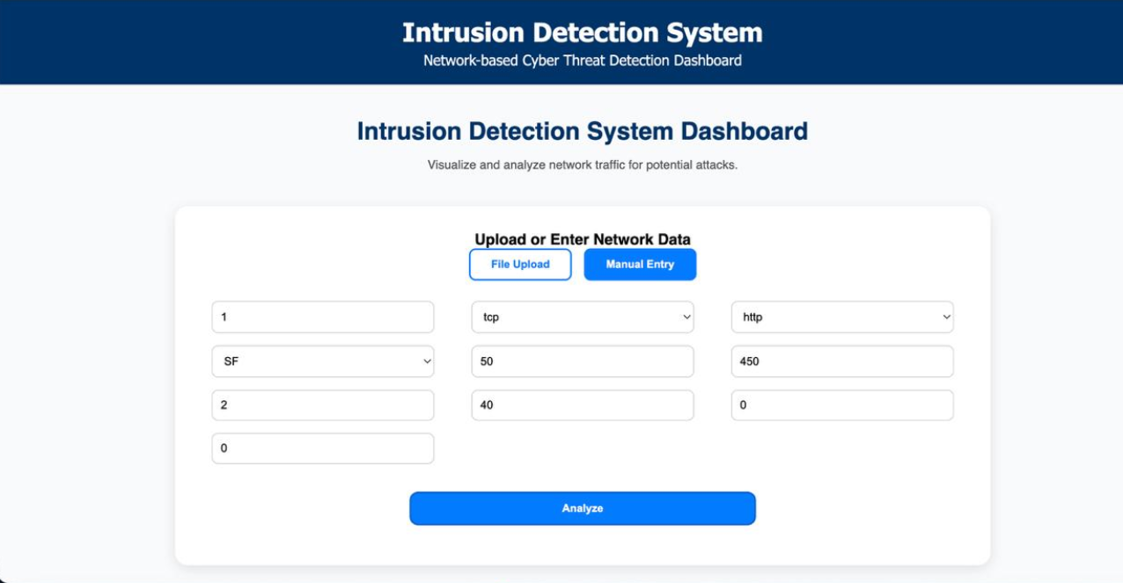

FIGURE-2: INTRUSION DETECTION DASHBOARD

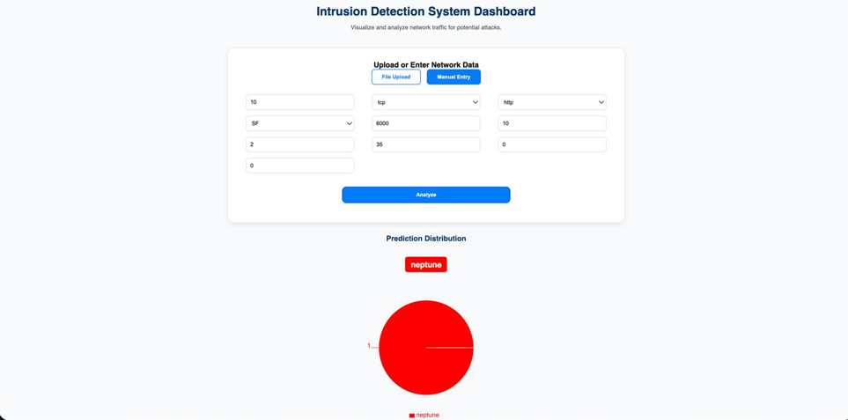

FIGURE-3: INTRUSION PREDICTION OF NEPTUNE ATTACK

CONCLUSION
It is an AI-based Intrusion Detection System (IDS) that is aimed at offering real-time cybersecurity to Industry 4.0 smart manufacturing facilities. Through the analysis of features of industrial network traffic produced due to the interconnection of IIoT devices, controllers and cyber-physical systems, the system recognizes correctly both the normal operation of the industry and the possible intrusion attempts.
Through structured data preprocessing and the implementation of the XGBoost machine learning algorithm trained on the NSL-KDD benchmark dataset, the proposed IDS extracts meaningful, data-driven insights to strengthen industrial network security. The model is optimized to balance detection accuracy with computational efficiency, ensuring suitability for latency-sensitive smart factory infrastructures.
This system combines a user-friendly monitoring dashboard developed with the help of React.js with the FastAPI based on which preprocessing, model execution, and the delivery of predictions in real time is processed. The proposed solution will provide a reliable and dependable way of monitoring because of the seamless operation between the monitoring interface and the intelligent detection engine, thereby facilitating automated and real-time detection of threats, so that the intelligent digital ecosystems of the industry 4.0 will not be reliant on manual supervision. Finally, the system helps to protect smart manufacturing processes against transforming cyber threats as well as assisting safe digital transformation.

ACKNOWLEDGMENTS
We would like to express our profound gratitude to our internal guide, Usha Rani Munagoti, Assistant Professor, Dept of IT on her valuable encouragement, positive comments and complete support to write our paper.

We take this opportunity to express our sincere gratitude to Dr.Y.J. Nagendra Kumar IT Head, and coordinators Mr.P.K Abhilash who were in support of the whole completion of the paper.

In particular, we would like to note that Dr. Jandhyala N. Murthy, the Director of GRIET and Dr. J. Praveen, the Principal of GRIET supported and encouraged us and helped to deliver the academic work and paper work in a smooth manner. We would also like to express our deepest gratitude to everyone at GRIET College, Hyderabad, including teaching and non-teaching staff, who supported and encouraged us in terms of academic and paper work.

REFERENCES

[1] K.-A. Tait, J. S. Khan, F. Alqahtani, A. A. Shah, F. A. Khan, M. U. Rehman, W. Boulila, and J. Ahmad, "Intrusion Detection using Machine Learning Techniques: An Experimental Comparison," 2021.
[2] M. A. Kumaar et al., "Hybrid Framework for Intrusion Detection in Healthcare (ImmuneNet)," 2022.
[3] Z. Li, "Toward Deep Learning based Intrusion Detection System," 2024.
[4] B. Buyuktanir et al., "Federated Learning in Intrusion Detection: Advancements, Challenges, and Future Directions," 2025.
[5] R. Kumar and M. Singh, "Hybrid Deep Neural Networks for Intrusion Detection," 2024.
[6] L. Zhao and P. Chen, "Anomaly Detection in Network Security using Autoencoders and Feature Fusion," 2023.
[7] S. Ahmed and R. Patel, "Blockchain-Enabled Intrusion Detection Framework for Secure IoT Networks," 2025.
[8] H. Lee and D. Park, "Transfer Learning Approaches for Network Intrusion Detection," 2024.
[9] J. Moreno and K. Gupta, "Optimized CNN Models for Lightweight Intrusion Detection for Edge Devices," 2023.
[10] A. Sharma and L. Rodrigues, "A Survey on Explainable AI (XAI)-Based Next-Generation Intrusion Detection Systems," 2024.

